Special Session: Life-Cycle Resilience of Civil Infrastructures under Climate Change

Civil infrastructure plays a vital role in ensuring community stability and economic growth, but its long-term performance is increasingly threatened by structural aging and the escalating frequency of extreme weather events driven by climate change. Consequently, there is an urgent need to shift the paradigm from static, component-level reliability towards dynamic, system-level life-cycle resilience to evaluate better how systems withstand, adapt to, and rapidly recover from both gradual deterioration and sudden climate-driven shocks.
Against this background, this special session aims to differentiate from conventional reliability studies by bringing together researchers and practitioners to disseminate recent advances in the life-cycle risk, adaptation, and resilience of civil infrastructures. Original research contributions, state-of-the-art developments, and innovative applications are highly encouraged to address these emerging global challenges over the entire structural service life. The list of topics includes, but is not limited to:
- Life-cycle performance and resilience assessment of infrastructures
- Impact of climate change on infrastructure reliability and safety
- Climate adaptation and mitigation strategies for civil engineering systems
- Time-dependent reliability and deterioration modeling under non-stationary environments
- Resilience-based design, operation, and maintenance optimization
- Multi-hazard risk assessment over the structural life cycle
- Life-cycle cost analysis and sustainability of aging infrastructures

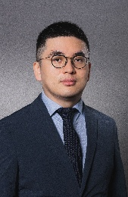 | 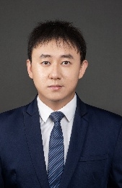
Chair: You Dong, The Hong Kong Polytechnic University, Hong Kong, China  Prof. You Dong is an Associate Professor in the Department of Civil and Environmental Engineering at The Hong Kong Polytechnic University. His research focuses on performance-based engineering, life-cycle reliability, and the resilience assessment of civil infrastructures under multiple hazards and climate change. He has published extensively in top-tier journals regarding structural safety, climate adaptation, and risk management. (E-Mail: you.dong@polyu.edu.hk) | Chair: Hongyuan Guo, The Hong Kong Polytechnic University, Hong Kong, China  Dr. Hongyuan Guo is a Research Assistant Professor in the Department of Civil and Environmental Engineering at The Hong Kong Polytechnic University. His main research interests include the life-cycle resilience of engineering structures, multi-scale structural modeling, and the performance assessment of critical infrastructures (e.g., wind turbines) under complex environmental loads. (E-Mail: hong-yuan.guo@connect.polyu.hk)

