The 16th International Conference on Quality, Reliability, Risk, Maintenance, and Safety Engineering (2026 QR2MSE)
July 22-25, 2026, Qingdao, Shandong, China
Special Session on: Physics-Informed AI for Reliability Engineering and Intelligent Maintenance
In critical domains such as manufacturing equipment, production systems, energy assets, and aerospace systems, reliability and maintenance decisions are becoming increasingly complex. Purely data-driven AI methods often lack physical consistency and extrapolation capability, while pure physics-based models struggle to adapt to dynamic operating conditions and real-time data. The integration of AI with physical information, that governs degradation mechanisms, failure physics, and operational dependencies, is essential to achieve accurate, interpretable, and timely predictive maintenance and reliability management strategies. This special session focuses on physics-informed AI approaches that fuse multi-source data (test, design, sensors, operational logs, environmental conditions) with physical knowledge to enable full lifecycle reliability design, degradation modeling, fault diagnostics, and intelligent maintenance decision-making, etc. Special attention is given to online dynamic planning and rapid adaptation to unexpected events such as sudden breakdowns or production schedule changes.
Original research contributions, state-of-the-art developments, and innovative applications in the following areas are particularly welcome:
- Multi-source data fusion with physical constraints for full lifecycle reliability design
- Physics-informed AI for degradation modeling and RUL prediction
- Hybrid AI-physics models for condition monitoring and fault diagnostics
- Physics-guided reinforcement learning for dynamic maintenance optimization
- Digital twin integrated with physics-informed AI for predictive maintenance
- Case studies in manufacturing, production systems, energy equipment, and aerospace systems, etc.
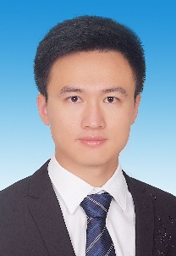 | 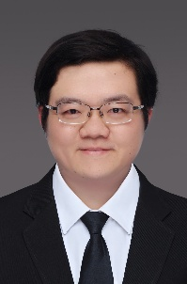 | 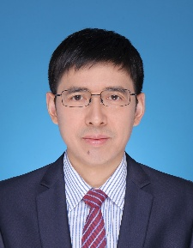
Assoc. Prof. Zhen Chen  Shanghai Jiao Tong University, China  Email: chenzhendr@sjtu.edu.cn | Prof. Tangbin Xia  Shanghai Jiao Tong University, China  Email: xtbxtb@sjtu.edu.cn | Prof. Ershun Pan  Shanghai Jiao Tong University, China  Email: pes@sjtu.edu.cn

