The 15th International Conference on Quality, Reliability, Risk, Maintenance, and Safety Engineering (QR2MSE2025)
July 23-26, 2025, Hohhot, Inner Mongolia, China
Special Session: Intelligent prognostics and health management (PHM) for engineering systems
Modern engineering systems are undergoing advancements in complexity and interconnectivity, driven by smart technologies such as AI, IoT, and digital twins. While these innovations enable higher efficiency and automation, they also introduce multifaceted challenges in sustaining operational performance. There is an urgent need for cutting-edge methodologies to address evolving demands in anomaly detection, predictive analytics, and adaptive maintenance—critical for mitigating risks in increasingly dynamic and data-rich environments.
Fault Diagnosis, Prognosis, and Maintenance represent pillars of advanced system health management. Fault Diagnosis requires advanced techniques for real-time anomaly detection, tackling challenges like sparse sensor data, noise interference, and cross-domain signal fusion. Prognosis demands robust models to forecast degradation and RUL, integrating uncertainties from heterogeneous operational conditions. Maintenance is not merely a reactive process but a proactive approach to ensure long-term system reliability and performance.
Therefore, this special Session aims to present research on the Intelligent prognostics and health management (PHM) for engineering systems, spanning diverse applications: power system (e.g., generation, distribution system, etc.), infrastructure system (e.g., highways, pipelines, etc.), offshore systems (e.g., wind turbines, oil and gas platforms, etc.), subsea systems (e.g., Christmas tree, subsea pumps, etc.), Manufacturing systems (e.g., CNC machines, production lines), and other types of system. Topics of interest include, but are not limited to, reliability design, failure analysis, fault diagnosis, fault prognosis, maintenance optimization, risk analysis and resilience evaluation. Other related topics are also welcome.
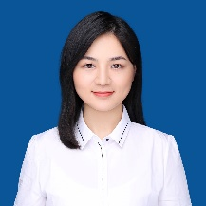  Dr. Yixin Zhao  China University of Petroleum (East China), Qingdao, China  Email: yixinz@upc.edu.cn | 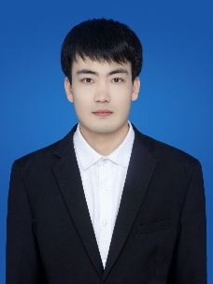  Dr. Gan Li  China University of Petroleum (East China), Qingdao, China  Email: ligan_2018@163.com

