The 15th International Conference on Quality, Reliability, Risk, Maintenance, and Safety Engineering & The 8th International Conference on Materials and Reliability
(QR2MSE2025 & ICMR2025)
July 23-26, 2025, Hohhot, Inner Mongolia, China
Special Session on: Trustworthy Safety in Engineering Assets
With the increasing complexity and integration of modern engineering assets, ensuring their reliability, safety, and risk mitigation has become a pressing concern in both academia and industry. The advancement of intelligent systems and digital twin technologies offers new opportunities to enhance system performance and dependability. However, engineering assets often operate in harsh environments, with limited maintenance resources and complex multi-domain interactions. Offshore renewable systems, such as wind turbines and wave energy converters, face persistent reliability challenges arising from fatigue, corrosion, and dynamic loads. Their electromechanical components and structural foundations remain vulnerable throughout their lifecycle. Meanwhile, the growing use of applied-AI technologies in industrial processes provides new avenues for intelligent monitoring and anomaly detection. These techniques enable non-contact, real-time assessments of system conditions and play an increasingly critical role in supporting predictive maintenance and failure prevention in complex systems.
Challenges such as structural degradation under harsh conditions, uncertainty in multi-modal sensor data, and the lack of interpretable decision-making frameworks demand new solutions. Modern engineering systems generate massive amounts of heterogeneous data. Effectively integrating these data sources to extract meaningful health indicators and actionable insights remains a key bottleneck. These challenges highlight the need for intelligent, interpretable, and trustworthy reliability technologies that bridge physical understanding and AI-driven insights. Such approaches are essential to ensure long-term performance, optimize maintenance strategies, and reduce safety risks in next-generation engineering systems.
This special session aims to present original research on advanced methods for ensuring the reliability, safety, and risk mitigation of engineering assets, offering innovative ideas for academia and practical applications for industry.
 | 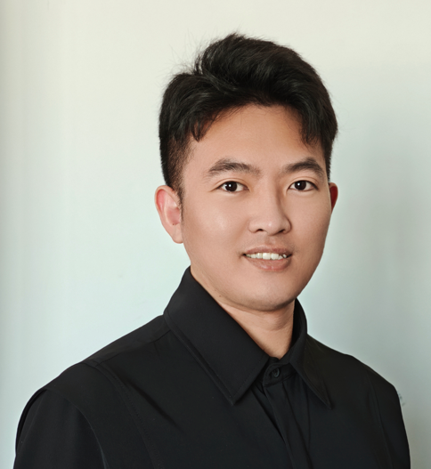 | 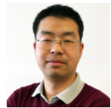
Dr. Zifei Xu  University of Liverpool, UK  Email: zifei.xu@liverpool.ac.uk | Dr. Yu Sun  Harbin Engineering University, China  Email: sunyu9@hrbeu.edu.cn | Prof. Xu Cheng  Tianjin University of Technology, China  xu.cheng@ieee.org

